RESOLUTION NO.__________

RE: CERTIFICATE OF APPROPRIATENESS UNDER THE
PROVISIONS OF THE ACT OF THE PENNSYLVANIA
LEGISLATURE 1961, JUNE 13, P.L. 282 (53
SECTION 8004) AND BETHLEHEM ORDINANCE NO.
3952 AS AMENDED.

WHEREAS, it is proposed to remove the rear tent and replace with pergolas at 313 E. Third Street.

NOW, THEREFORE, BE IT RESOLVED by the Council of the City of Bethlehem that a Certificate of Appropriateness is hereby granted for the work.

Sponsored by: (s)

(s)

ADOPTED BY COUNCIL THIS DAY OF

(s)
President of Council

ATTEST:

(s)
City Clerk

HISTORIC CONSERVATION COMMISSION

CASE # 565 – It is proposed to remove rear tent and replace with pergolas at 313 E Third Street
OWNER/APPLICANT: Jeannie Agentis Revocable Living Trust/ Bill & Sue Dech

The Commission upon motion by Mr. Cornish seconded by Mr. Evans adopted the proposal that City Council issue a Certificate of Appropriateness for the proposed work described herein:
- The proposal to remove the rear tent and replace with pergolas at 313 E Third Street was presented by Bill & Sue Dech.
- The existing tent will be replaced with a large wood pergola as per scaled drawings submitted and the following details:
  - The wood posts will be attached to the concrete foundations with the appropriate Simpson Strong-tie metal brackets. The posts will not be imbedded in concrete.
  - The wood posts will have stop chamfers on the corners starting 18” above the Simpson brackets and stopping 12” below the top metal brackets.
  - All brackets and metal will be painted black.
  - There will be no clear corrugated covering over the new pergola.
  - The wood pergola will be stained. The color will be determined with the HCC at their next meeting.
- The proposed motion was unanimously approved.

CU: cu
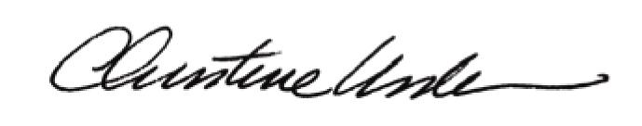

By:

Date of Meeting: August 23, 2015 Title: Historic Officer

